Customer Info

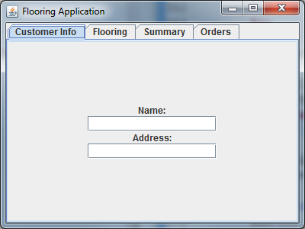

# Customer Info Tab

The Customer Info tab has 2 properties:

* Name
* Address

In the *Name* textbox goes the person’s name.

In the *Address* textbox goes the person’s address.

Flooring

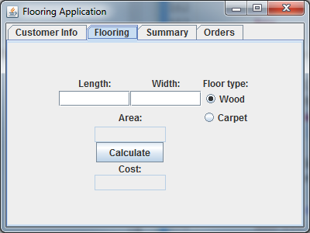

# Flooring Tab

The Flooring tab has several properties:

* Length & Width
* Floor Type
* Area
* Cost

In *Length* and *Width* go the dimensions of the floor.

In *Floor type* select the desired material.

The *Area* & *Cost* will be shown after pressing the *Calculate* button.

*Cost* is calculated by multiplying the **Area** and the cost of the selected **Floor type**.

Summary

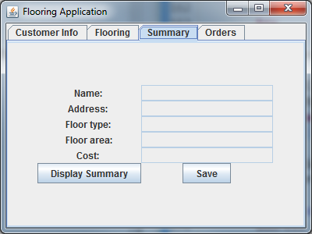

# Summary Tab

The Summary Tab has the following properties:

* Display Summary Button
* Save Button

The *Display Summary* button, as the name indicates, displays a summary of what has been typed. It is best to ensure that all your information is valid by pressing Display Summary before hitting the *Save* button.

The *Save* button stores the person’s information and selections in the database.

Orders

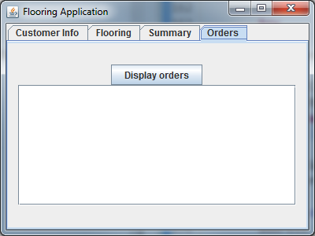

# Orders Tab

The Orders tab has the following property:

* Display Orders Button

The *Display Orders* button retrieves all the orders from the database and displays them in the text area below.